Blockchain in Sri Lanka
Blockchain is a buzzword that has been loosely flung around to represent anything that means cryptocurrency. But in the more formal definition as an immutable ledger, how can this technology really benefit the developing world, and more specifically, Sri Lanka? Given our disproporationate weightage in GDP to Services, we examine the most promising sub-sector, banking and finance, which contributes 11.5% to the services sector GDP. Summarise
Figure 1: A breakdown of Sri Lanka’s GDP by sector

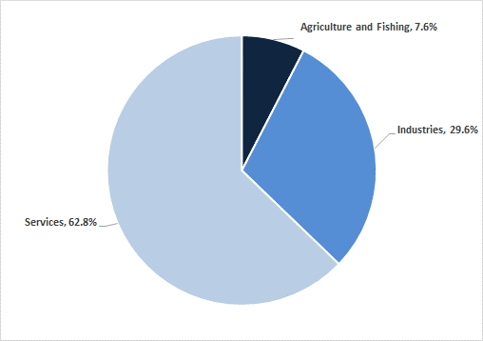
Source: Moody’s Analytics Knowledge Services, Ministry of Finance 2017 report

Blockchain banking – most significant opportunity in Cross boarder payments
Banking is a key focus point globally for blockchain implementation. Multinational banks are conducting numerous PoCs to test various blockchain applications across their verticals. Because of the inherent advantages discussed at the beginning of this paper, blockchain solutions promise greatly improved efficiency in terms of payment processing and automation, reduced labor, and increased security – all factors that trickle down to the P&L. A recent study by Accenture and McLagan showed that within investment banking, operations such as cash management and payments, inventory and collateral management and clearing and settlement could achieve >70% potential cost savings.
Metric | Traditional | Internet banking | Blockchain-enabled
Customer service | - Single scenario  - Homogenous | - Many scenarios  - Customized | - Many scenarios  - Customized
Efficiency | - Many intermediate links  - Complex clearing process | Many intermediate links  Complex clearing process | - Point-to-point transaction
Cost | - Manual inspection  - High compliance costs | Little manual inspection  High-intermediate compliance costs | - Automated  - Little or no compliance required
Security | - Centralized data storage; can be tampered with and information leaked  - Little/no encryption | - Centralized data storage; can be tampered with and information leaked  - Some level of encryption | - Decentralized; cannot be tampered with  - Encrypted securely

Source: Moody’s Analytics Knowledge Services, Guo and Liang’s report on ‘Blockchain application and outlook in the banking industry’
One of the strongest use cases of blockchain is in payment authorization and settlement, primarily due to the highly transaction-based nature of the service. According to Centric Digital, blockchain use is expected to be as high as 79% for payment authorization and settlement and 77% for cross-border payments (vs. just 44% for identity management). Ripple is a real-time gross settlement system, currency exchange and remittance network currently being adopted by banks in both developed and emerging markets. Ripple can reduce transfer times, and compliance and liquidity costs significantly; customer banks can save 33% on international payments via savings from a 65% reduction in liquidity costs, a 48% drop in payment operations costs, and a 99% decline in Basel III compliance costs, according to the company. Given that Sri Lanka has a large number of citizens employed overseas (remittance inflow is c.10% of GDP), a Ripple-like blockchain solution could reduce costs and speed up remittance transfer significantly.

Case Scenario: Using Blockchain to Speed Up Global Settlements
In Vietnam, blockchain-powered next-generation global settlement platform OKLink announced the launch of real-time transfers. The platform can transfer up to USD10,000 to a Vietnam bank account, cash pickup, or mobile wallet for a total delivery fee of 0.5% within just 30 minutes.
Sri Lanka is not quite there yet, but banks are beginning to experiment with the technology internally (i.e., operating within a single entity’s ecosystem/without a partnership). In June 2018, Sampath Bank launched Sri Lanka’s first blockchain-based payment system, attracting 70,000 customers at launch. The application, called Sampath igift, enables all bank account holders to gift a specified amount of money to anyone on their smartphones’ contact lists via a blockchain system.

Industry-wide collaboration core of blockchain establishment in Banking and Finance?
Peers have recognized the evident advantages of adopting blockchain and are working on developing an innovation-conducive landscape for the technology via widespread collaboration. As the banking industry relies heavily on the flow of money, the greatest value contribution will accrue only if the banks themselves collaborate to develop a shared blockchain architecture.
Evidence for this requirement is rife; in Indonesia, five major banks – Bank Negara Indonesia (BNI), Bank Rakyat Indonesia (BRI), Bank Mandiri, Bank Danamon, and Bank Permata – are collaborating with IBM to develop a blockchain platform for banks. The network is currently in use by members of Advanced Pacific Financial Infrastructure for Inclusion (APFII), a public-private partnership initially funded by the United Nations and SWIFT (expected to process up to 60% of all cross-border payments in the South Pacific's retail foreign exchange corridors by early 2019). Similarly, in Thailand, 14 banks (including Bangkok Bank, and Krung Thai Bank) are collaborating to digitize letters of guarantee to state-owned enterprise auctions on a shared blockchain. The system will be tested on the Thai central bank's ‘sandbox’ and will use IBM’s Hyperledger Fabric technology.
Sri Lanka still has to make progress on the collaboration front. Sri Lankan banks are experimenting with and have established some MVPs on an internalized scale, but yet lag behind peers’ large-scale collaborative efforts.

What are the key areas of impediment for blockchain?
According to the 2018 Market Survey Report for applications of blockchain in China, the key issues plaguing BCT are a lack of standardization for policy, talent and understanding, facets that were bought up insistently by the industry experts we talked. Furthermore, the severe lack of understanding and motivation from political standpoint also lead to a vicious cycle of lagging behind.
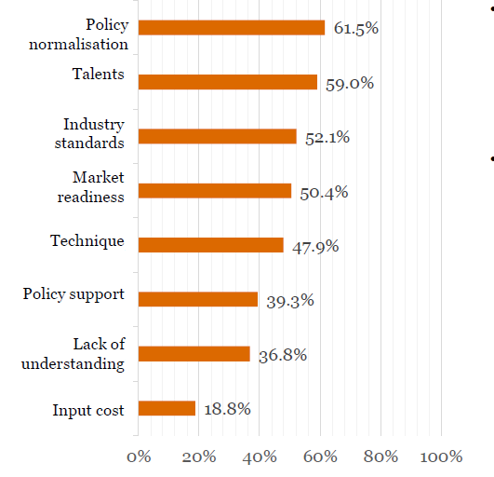
Source: https://www.pwccn.com

